Introducing USC IMSC for International Collaborative Research

Abstract:

Integrated Media Systems Center (IMSC) at the University of Southern California is a research center that focuses on data-driven solutions for real-world applications by applying multidisciplinary research in the area of data science. We find enhanced solutions to fundamental Data Science problems and apply these advances to achieve major societal impact. To this end, we target four application domains: Transportation, Health, Media and Entertainment, and Smart Cities. For each domain, we develop large-scale System Integration Prototypes designed to address real-world problems as well as to conduct fundamental and applied multidisciplinary research in data science. Founded in 1996 as an NSF ERC (National Science Foundation Engineering Research Center), IMSC is hosted by the USC Viterbi School of Engineering and benefits from the support of the School’s Faculty and Staffs. IMSC has been an energetic force in the expansion of the USC Viterbi School of Engineering, serving as the catalyst for new curricular programs and continuously expands education and research efforts with international programs and collaborations. This talk introduces recent research activities at IMSC and ways of international collaboration between USC and Korea University.
Bio
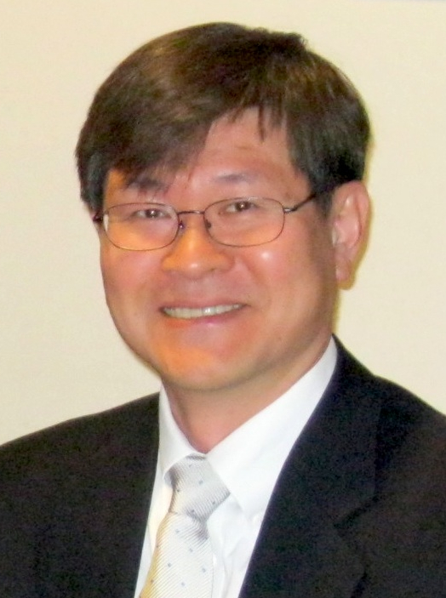
Dr. Seon Ho Kim is a Research Scientist and Associate Director in the Integrated Media Systems Center (IMSC) at the University of Southern California. He is also a parttime faculty of the Data Science program in the Viterbi School of Engineering at USC. Before joining IMSC, he worked at the University of Denver as a faculty member. Dr. Kim was the President of KOCSEA (Korean Computer Scientists and Engineers Association in America) in 2017. He is also the founder and president of SoDAVi (Social Data Analysis and Visualization) Group, a non-profit organization which aims for providing data collection and analysis service to Korean-American community in Southern California. He received his BS degree in Electronic Engineering from the Yonsei University, Seoul, Korea in 1986. He also received his MS in Electrical Engineering and Ph.D. in Computer Science from the University of Southern California, Los Angeles, USA, in 1994 and 1999, respectively.

Dr. Kim's primary research interests include multimedia systems, databases, Big Data, image machine learning, IoT, and mobile media data management, where he has more than 90 publications including a textbook, patents, major journal papers, and top conference papers. Recently, his work received best paper awards at the IEEE Big Multimedia Conference two years in a row in 2018 and 2019. His team also won the First Place at IEEE Big Data 2020 Global Road Damage Detection Challenge. He has been serving the research community as a conference program committee member, journal editorial board member and reviewer. Dr. Kim’s projects have been funded by US federal and local governments, industries such as Google, Northrop Grumman Corp., Microsoft, Oracle, and Intel.

